**Year 9 Creative Media Production**

**App Design**

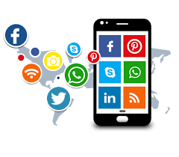

Name: _______________________________

Teacher: _____________________________

**Lesson 1**

**Introduction -** An **app** is a computer program (also known as a software **app**lication) designed to run on a mobile device such as a smartphone, tablet or smartwatch.

**Task 1 - What do we know about apps?**

First of all, see if you can name ten apps that you – or people you know – use a lot:

1. ________________________________
2. ________________________________
3. ________________________________
4. ________________________________
5. ________________________________
6. ________________________________
7. ________________________________
8. ________________________________
9. ________________________________
10. ________________________________

Now, choose three apps you know well and name up to three things it helps you do…

**App Name 1:** _____________________________________

This helps you to…

1. _________________________________________
2. _________________________________________
3. _________________________________________

**App Name 2:** _____________________________________

This helps you to…

1. _________________________________________
2. _________________________________________
3. _________________________________________

**App Name 3:** _____________________________________

This helps you to…

1. _________________________________________
2. _________________________________________
3. ________________________________________

**Features of a Mobile phone**

Put the features of a mobile phone in order of which matter to you the most. In the first 3 boxes, put the features you look for in a smartphone. In the middle boxes put the features you might not use very often and in the last 3 boxes put the features that you could live without.

**Look for**

**Look for**

**Not use often**

**Not use often**

**Not use often**

**Live without**

**Live without**

**Look for**

**Task 2 – Smartphone uses for specific types of people**

It is important that our smartphones and mobile devices meet the needs and wants of our target market.

In the boxes on the **next page**, write in the features of a smartphone that you think will be useful for a teenager, a business person and an elderly person. Also explain how they could use them in their daily lives.

If you need help getting started, you could choose from the uses listed below. You should aim to also use some of your own ideas of different uses we have for smartphones.

|  |  |  |
| --- | --- | --- |
| Make Phone Calls | Send Messages (Text) | Internet Access |
| Install Apps | Games | Play Music/Video |
| Camera | Bluetooth | Send Emails |

|  |  |  |
| --- | --- | --- |
| **Teenager** | **Business Person** | **Elderly Person** |
| Features:  Explain how they could use them in their daily lives: | Features:  Explain how they could use them in their daily lives: | Features:  Explain how they could use them in their daily lives: |

**Lesson 2**

**Task 1 – Designing useful and appropriate apps**

Now we are going to think about everyday problems that we face and how they might be helped by having an appropriate app…

**Problem 1:**  Missing the bus

**Solution:** app tracks your specific bus; sends updates about where it is…

**Tools:** GPS, notifications…

**Problem 2:**

**_____________________________**

**Solution:**

**_____________________________**

**Tools:**

**______________________________**

**Everyday Problems**

**What do you find difficult on a daily basis: Getting up? Getting to school on time?**

**Problem 4:**

**___________________________**

**Solution:**

**____________________________**

**Tools:**

**____________________________**

**Problem 3:**

**___________________________**

**Solution:**

**___________________________**

**Tools:**

**____________________________**

**Problem 3:**

**___________________________**

**Solution:**

**____________________________**

**Tools:**

**____________________________**

**Task 2 – Designing your own app**

Now decide on **one** problem from those you listed on the last task.

First, let’s decide on a name for your app. Look back at the real apps you’ve listed in previous tasks and think about their names.

Choose one real app name you like and answer the following questions.

1. What sort of title does it have – does it have one word or more?

__________________________________________________________________

1. Does the title use an ordinary word(s), or is it something new/made up/original?

__________________________________________________________________

1. What other words does the title remind you of? Make a list:

__________________________________________________________________

1. Do you think the title makes people want to find out more about the app?

_________________________________________________________

Now think about the app you are going to design and make a list of **as many words related to it as possible**. (For example, words related to getting up in the morning could be: alarm; bed; sleep; sleepy; tired; late; etc.). After you have done this, decide on a final name for your app – try to be imaginative and make it catchy!

**Final Name –**

**Task 3 - App icons**

Your app will need an icon or logo that makes it interesting and appealing to phone/tablet users.

Now try **drawing an app icon** for your own app idea! There is space for 4 some smaller ones to try/sketch out some ideas and a bigger space for you to draw your final design.

**Why did you decide on your final app icon? (give 3 reasons)**







**Lesson 3**

**Task 1 - What your app will look like?**

Now you’ve come up with your idea for what it will be called and what will the app’s icon will look like, you now need to think about **what the User Interface (UI) might look like** when you open the app and use it**.**

Here are some examples, with a **home screen:**

[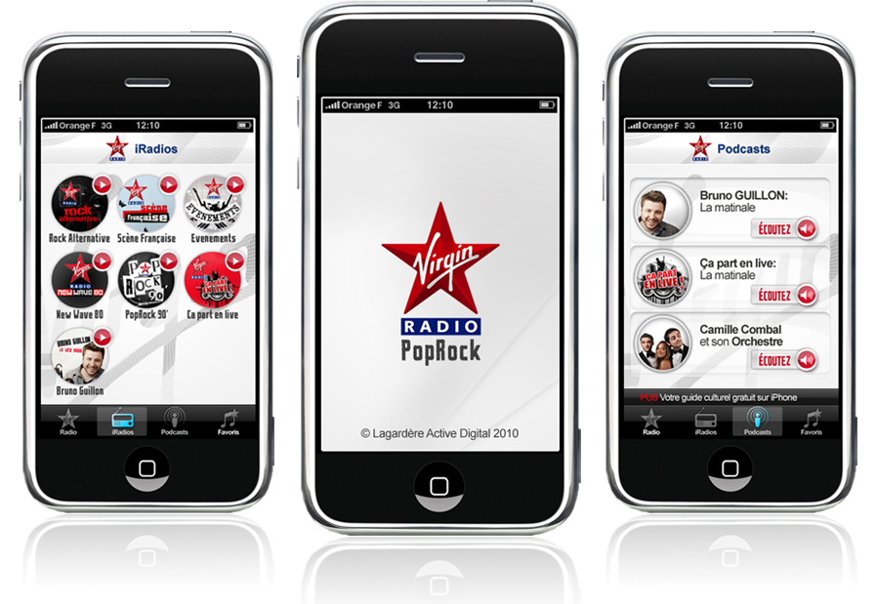](http://www.google.co.uk/url?sa=i&rct=j&q=app%20design&source=images&cd=&cad=rja&docid=ns2jc3Tiby0ncM&tbnid=NceidW21HsHlxM:&ved=0CAUQjRw&url=http://designyoutrust.com/designyoutrust/virgin-radio-fr-iphone-app-design-by-utopia/&ei=c7hCUuyCELKM7AbD_4GoCg&bvm=bv.53077864,d.ZG4&psig=AFQjCNG3UEUU03WkVjLAFs8UYRy-Crw8Tg&ust=1380190695273283)

[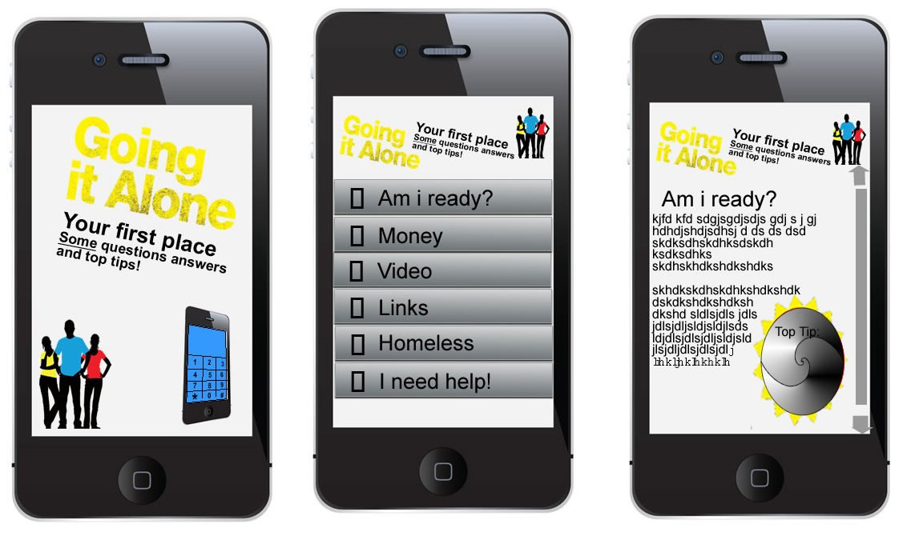](http://www.google.co.uk/url?sa=i&rct=j&q=app%20design&source=images&cd=&cad=rja&docid=AdFK7Z8jj3daaM&tbnid=MyZq6k0IILk1fM:&ved=0CAUQjRw&url=http://www.livetech.co.uk/mobile-app-to-help-north-wales-young-people-leaving-home-for-the-first-time&ei=4LdCUvnVNLKg7Abot4CYAw&bvm=bv.53077864,d.ZG4&psig=AFQjCNFAVDzd8xPicRDwomQpfsv6mPY0RQ&ust=1380190551791473)

Using the blank phone screens on the 2 next pages, you need to design between **4 and 8 screens** which could appear in your app**.** These could have **menus, buttons, graphics, maps video, audio, sharing facilities, or any other feature you can think of!** Use colour in your sketches to get a real sense of how your well your chosen **colour scheme** will work.

The purpose of this screen is:

____________________________

____________________________

________________________________

________________________________

The purpose of this screen is:

____________________________

____________________________

________________________________

________________________________

The purpose of this screen is:

____________________________

____________________________

________________________________

________________________________

The purpose of this screen is:

____________________________

____________________________

________________________________

________________________________

The purpose of this screen is:

____________________________

____________________________

________________________________

________________________________

The purpose of this screen is:

____________________________

____________________________

________________________________

________________________________

The purpose of this screen is:

____________________________

____________________________

________________________________

________________________________

The purpose of this screen is:

____________________________

____________________________

________________________________

________________________________

**Task 2 – Evaluation of your app**

Write a short evaluation of your app. Answer the following questions.

1. What is the purpose of your app?

1. Who would be the main users of your app?
2. What is a strength of your app?
3. What could be improved about your app?

1. How much would you charge for your app, if anything!



**You are one step closer to becoming the app designer everyone is talking about!**

**Teacher Feedback:**

**WWW:**

**EBI:**