Year 10 Creative Media Production
Name:
Component 2 – Redesigning a Magazine
Lesson 1
In your final assessment of Component 2, you will have to redesign (or ‘reimagine’) an existing magazine so that it meets a teen audience. You will have to select one of the following magazines:
- Vogue
- Dogs Monthly
- Rolling Stone
Over the next few lessons, you will practise redesigning existing an publication (i.e. a magazine cover). Look at the image of a magazine cover below. Fill in the gaps using these words:
Main cover line Puffs Props Masthead Graphic Date
Buzzword Barcode Tagline Main image Price

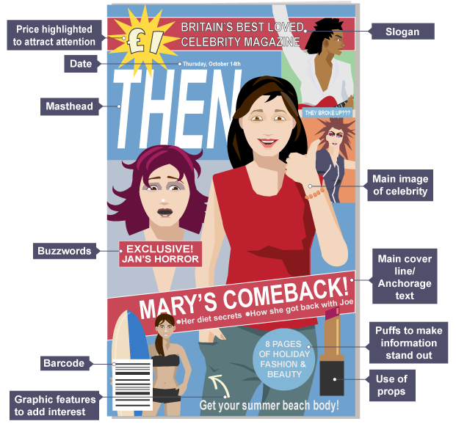

Challenge
Look around the house and try to find up to five different magazines.
For each magazine, fill in the table below. You must comment on:
- the genre of the magazine and what features of the design indicate its genre
- the target audience, including details such as gender, age group, interests, etc.
- how people are represented, e.g. do the photographs show stereotypes?
An example has been given to help you.
Title of Magazine | Genre? How do you know? | Target Audience – e.g. gender, age group, interests, etc. | Representation – e.g. is there any stereotyping?
Men’s Health | Health and lifestyle.  The bold title includes ‘Health’, which shows that it is about leading a healthy life. There is normally an in-shape celebrity on the front cover to add glamour and appeal. | Men  20s to 50s  Those who want to keep fit and healthy. | Even though it focuses on getting in shape, it does not exclude older men. One of the magazine covers features a man who is 55 years old.
Lesson 2
Your next challenge is to redesign the front cover of one of the magazines you have found, but for a different target audience (e.g. for a teenage audience).
Firstly, you must create a mood board below to represent the various elements of the design that will help the magazine to:
- meet its purpose, e.g. to inform, to entertain, etc.
- appeal to the target audience, e.g. content, language, font styles, etc.
- be easy to read, e.g. use of colour, font size, alignment, columns, etc.
You could include cuttings from magazines (e.g. of font styles you would like to use, of graphics that are eye-catching, etc.) and stick them into the mood board.

Lesson 3 – Thumbnail Layouts
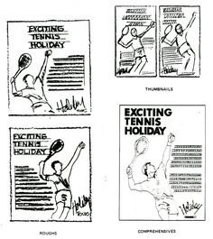
Your mood board will have given you a greater understanding of the design that needs to go into your chosen magazine cover.
As previously mentioned, your challenge is to redesign the front cover of the magazine for a different target audience (e.g. for a teenage audience).
To develop a clearer idea of what your new cover will look like, you will need to create some ‘thumbnail layouts’.
Thumbnail layouts are small sketches that give an indication of what the content of the page with be and how it will be laid out. Some examples can be seen on the right.
Challenge
Complete 6 thumbnail layouts of what your redesign of the front cover of your magazine could look like. Think about who will be featured on the front cover because you will have to write an article about them!

Lesson 4
Following on from the thumbnail layouts that you created, pick the one that you think is the best. What you need to do now is draw a bigger version of your front cover and annotate some of the details of it. What colours are you going to use, where and why? What font style might you use and why? What images are you using and why? What text will you use and why?

Lesson 5
An extremely important part of a magazine is its logo. Below are some examples of logos used in existing magazines.

Challenge
You now have to redesign the logo that appears on the magazine you have made a mood board and thumbnail layouts for. The logo must be ‘reimagined’ so that it appeals to your target audience.
In the table below, sketch three redesigns of the logo for your magazine and explain your decisions.
Logo Idea | Design | Explanation
1
2
3

Lesson 6 – Article Writing
You now need to practise your creative writing by producing an article for your magazine. The article should be about the person you featured on the front cover of your ‘reimagined’ magazine design.
Who is your article about?
Why have you selected them?
What is the title of your article?

Now you need to write out your article. Try your hardest to make it interesting. This is your chance to show how imaginative and creative you can be - be sensible though!

